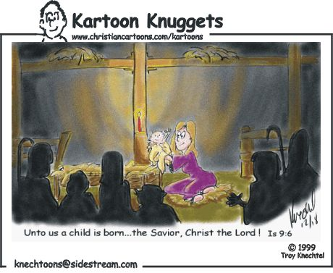


O magnify the LORD with me, and let us exalt his name together. Psalm 34:3
I will praise the name of God with a song, and will magnify him with thanksgiving. Psalm 69:30
Kartoon Knuggets used with permission

Wishing you the peace and joy of the real Christmas

from Rich & friends who bring you the
Crimson & White Connection
a ministry of prayer and encouragement through FREE mailings on character, values, and the Christian life.

and, as always, ...
Someone prayed for YOU and mentioned
YOU before God’s throne.
God bless and watch over you today.

FREE subscriptions to the C&WC mailings...
contact: RDymmel@AOL.com or go to www.CrimsonWhite.org

Kartoon Knuggets used with permission

Wishing you the peace and joy of the real Christmas

from Rich & friends who bring you the
Crimson & White Connection
a ministry of prayer and encouragement through FREE mailings on character, values, and the Christian life.
and, as always, ...
Someone prayed for YOU and mentioned
YOU before God’s throne.
God bless and watch over you today.

FREE subscriptions to the C&WC mailings...
contact: RDymmel@AOL.com or go to www.CrimsonWhite.org
cc60000ChristmasCards4.doc

For a FREE subscription to ~18 mailings a year contact: RDymmel@AOL.com or go to www.CrimsonWhite.org

Crimson & White Ministries
4401 Wild Oak Lane, Greensboro, NC 27406
You can download this card in Word or pdf formats from www.CrimsonWhite.org

C&WM mails “letters” of encouragement targeted at students, but read by all ages. Topics include character, morals, values, relationships, sex, devotional thoughts, and the Christian life. Write or email and ask for a free sample. Subscriptions are FREE after you’ve seen a sample.

cc60000ChristmasCards4.doc

For a FREE subscription to ~18 mailings a year contact: RDymmel@AOL.com or go to www.CrimsonWhite.org

Crimson & White Ministries
4401 Wild Oak Lane, Greensboro, NC 27406
You can download this card in Word or pdf formats from www.CrimsonWhite.org

C&WM mails “letters” of encouragement targeted at students, but read by all ages. Topics include character, morals, values, relationships, sex, devotional thoughts, and the Christian life. Write or email and ask for a free sample. Subscriptions are FREE after you’ve seen a sample.

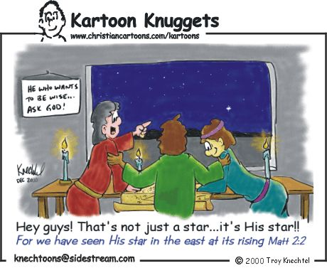
Wise men still seek Him.

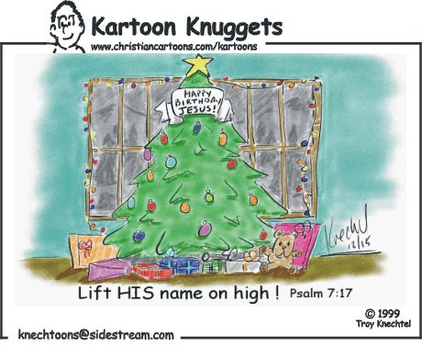
Kartoon Knuggets used with permission

Wishing you the peace and joy of the real Christmas

from Rich & friends who bring you the
Crimson & White Connection
a ministry of prayer and encouragement through FREE mailings on character, values, and the Christian life.

and, as always, ...
Someone prayed for YOU and mentioned
YOU before God’s throne.
God bless and watch over you today.

FREE subscriptions to the C&WC mailings...
contact: RDymmel@AOL.com or go to www.CrimsonWhite.org

Kartoon Knuggets used with permission

Wishing you the peace and joy of the real Christmas

from Rich & friends who bring you the
Crimson & White Connection
a ministry of prayer and encouragement through FREE mailings on character, values, and the Christian life.
and, as always, ...
Someone prayed for YOU and mentioned
YOU before God’s throne.
God bless and watch over you today.

FREE subscriptions to the C&WC mailings...
contact: RDymmel@AOL.com or go to www.CrimsonWhite.org
cc60000ChristmasCards4.doc

For a FREE subscription to ~18 mailings a year contact: RDymmel@AOL.com or go to www.CrimsonWhite.org

Crimson & White Ministries
4401 Wild Oak Lane, Greensboro, NC 27406
You can download this card in Word or pdf formats from www.CrimsonWhite.org

C&WM mails “letters” of encouragement targeted at students, but read by all ages. Topics include character, morals, values, relationships, sex, devotional thoughts, and the Christian life. Write or email and ask for a free sample. Subscriptions are FREE after you’ve seen a sample.

cc60000ChristmasCards4.doc

For a FREE subscription to ~18 mailings a year contact: RDymmel@AOL.com or go to www.CrimsonWhite.org

Crimson & White Ministries
4401 Wild Oak Lane, Greensboro, NC 27406
You can download this card in Word or pdf formats from www.CrimsonWhite.org

C&WM mails “letters” of encouragement targeted at students, but read by all ages. Topics include character, morals, values, relationships, sex, devotional thoughts, and the Christian life. Write or email and ask for a free sample. Subscriptions are FREE after you’ve seen a sample.

